Gloop Recipe

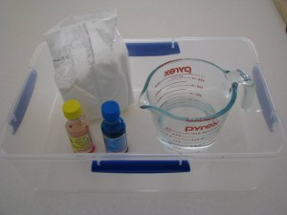
What you will need?

2 cups of cornflour
1 cup of water
Food Colouring
A large container or bowl

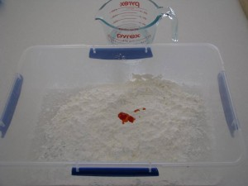
Place the cornflour into a large container
Place a few drops of colouring into the centre.
Have the water ready to pour into the container.

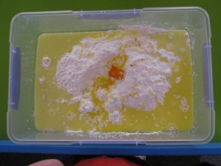
Mix the water into the cornflour and colouring.
It will take some time to mix together,
but encourage playing with the gloop before
it is mixed.
What does it feel like?

