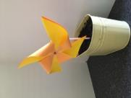
How to make a windmill

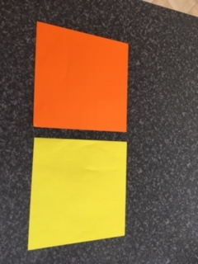 | Choose 2 squares of paper, the same size, in different colours
 | Put one sheet exactly on top of the other
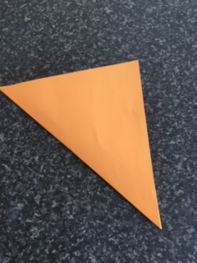 | Fold both sheets diagonally and unfold
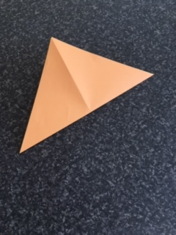 | Fold both sheets diagonally the other way
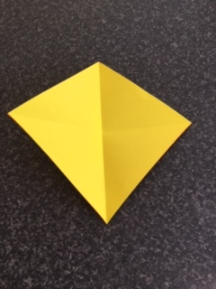 | unfold
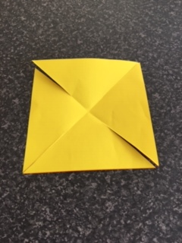 | Cut along each diagonal line until about 3cm from the middle (through both sheets of paper)
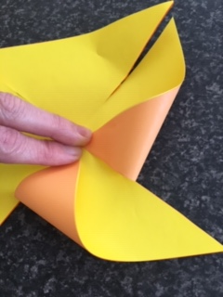 | Fold 4 alternate triangles into the middle, keep in place by holding with fingers
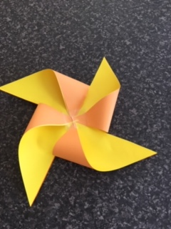 | Hold corners in the middle with tape or sticker
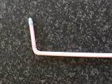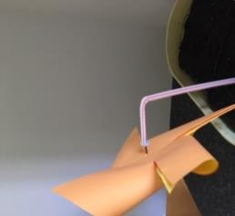 | Use a drawing pin or small nail to attach windmill to a dowling rod or wooden chop stick,  Or  Put bluetac in the end of a bendy straw, then push the pin/nail into the bluetac

