1. This is the back of the paper, usually white.
2. Fold the bottom corner up to the top corner and crease well.
3. Take the right points over to the left and make a small crease along the bottom edge to mark the middle. | 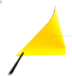
4. Unfold the previous step. | 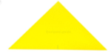
5. Take the right point and bring it up and to the right at an angle away from the top point.
6. Do the same thing on the left side, try to make it match the right side.
7. Fold the bottom point up a little, to form the cat's chin.
8. Flip the cat over to the other side. | 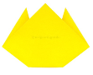
9. Fold the top points down, until it reaches to about where the left and right points would line up.
10. You can fold just one layer behind to have a two coloured cat, or fold both of the layers behind. | 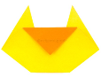
11. Flip the cat over to the other side and fold the left and right points in a little to round out the face. | 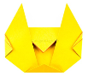
12. The origami cat face is complete! | 