Steps Challenge!

Set your own steps challenge:
climb one of these buildings/mountains over several weeks

Round tower at Windsor Castle  200 steps | 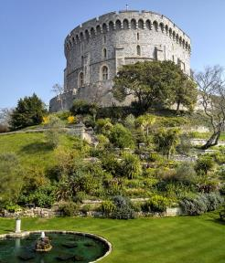
Millennium Dome  320 steps | 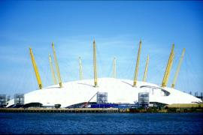
Big Ben  632 steps | 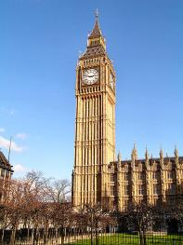
The Eiffel Tower  1665 steps | 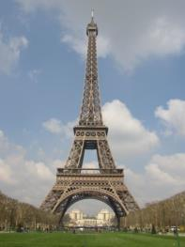
Mount Snowdon  7120 steps | 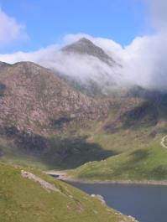

Date | Number of steps
Total number of steps:

