Plastic bottle bird feeder

This is a great autumn craft for homeschooling families, or a fun weekend activity for folks of all ages. When you create yours, keep in mind that the kind of see you use will determine what kind of avian visitors you get: sunflower seeds will attract chickadees and nuthatches, while mixes that contain millet and other small seeds will draw sparrows, finches, and grosbeaks. If you’re using a really heavy-duty plastic container (like a large milk jug), you can fill it with corn and peanuts: you’ll have jays, magpies, and woodpeckers stopping by for a snack in no time.
Related: How to Make a Bird Feeder for Small Spaces from Recycled Materials

What You’ll Need:
- An empty plastic bottle with a lid or cap (from a water bottle to a large juice container) – washed and dried thoroughly
- Utility knife
- Washer or nut
- Household twine
- Strong glue
- A bamboo skewer or wooden chopstick, or even an unsharpened pencil
- Birdseed

Step 1:
Use your utility knife to poke a hole at the bottom of the container, as well as its cap/lid. Then, use the knife to cut out a circle of plastic on one side of the feeder, approximately 1 inch in diameter. This hole should be half an inch to an inch above the bottom; a good rule of thumb to follow is that it should be above the ridge or curve at the bottom of the container.
Related: How to Make Suet Winter Bird Feeders

Step 2:
Take that trusty utility knife and poke a hole directly beneath that feeding hole. Feed your skewer through it until it pokes against the container’s back, and then poke a hole on that side as well. You’ll feed just enough of your skewer (or chopstick) through that back hole so it can be secured, but not protrude too much. Take your glue and use it liberally around the outside of that protrusion to hold the skewer in place. This keeps glue away from the feeding hole, but will keep the perch from sliding away.

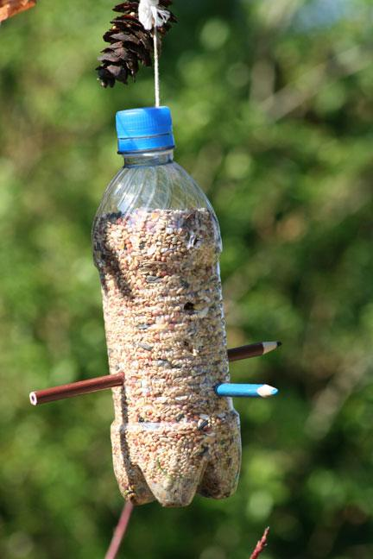

Note: If you’re using a fairly large container, feel free to carve a 1-inch hole on either side, and push the skewer all the way through so at least 1 inch sticks out on either side. This will allow 2 birds to eat at the same time, so you’ll draw more wildlife to your yard, but there won’t be as many fights over who gets to eat first.

Step 3:
Cut a length of string approximately 20 inches in length. Tie one end around the washer, and feed the free end in through the bottom of your plastic container, and out through the top of its cap or lid. Close the cap tightly, and tie a knot on top of it to keep it in place.

Step 4:
Pour birdseed into the bottom of the container through one of the holes that you cut, and then hang your feeder near a window, or on a nearby tree branch or outdoor hook, and you’ll have feathery visitors in no time! Just remember to keep the feeder topped up, as local birds will come to depend on you as a food source.

