Pressing flowers

When I was a little girl I loved to dry and press flowers. I had them hanging in my room, randomly placed in books and stored in little bottles like potpourri all over the house.
Recently, my six-year-old daughter has shown an interest in collecting things from nature; leaves, feathers, rocks and sticks are among the favourites. When I shared with her my childhood passion for pressing flowers she was, in her words ‘so excited to try’. So with a garden full of flowers, we got started.

Supplies
Garden flowers
Heavy book (old phone book is perfect for this purpose)
Baking paper

How to Press Flowers

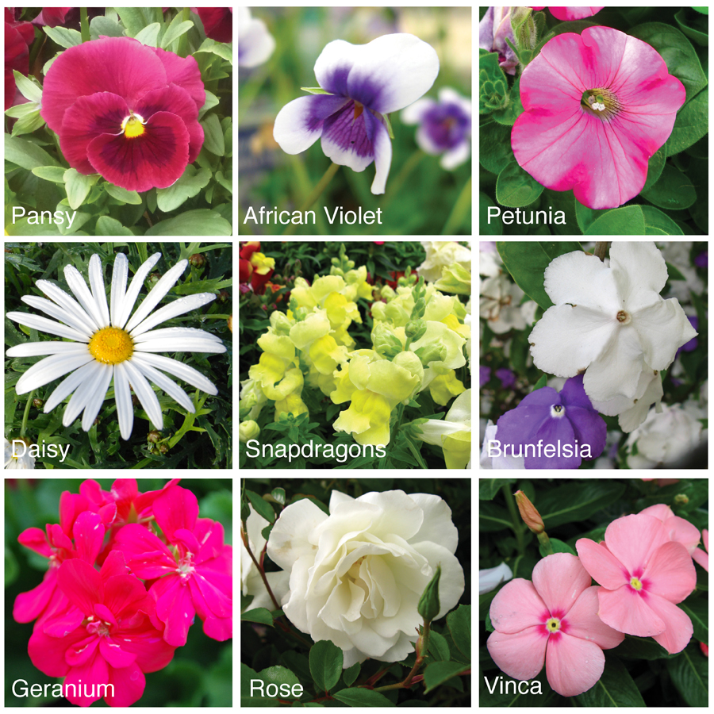
Step 1: Picking the Right Flowers
The main issue faced when pressing flowers is mold, which is caused when a section of the flower is taking too long to dry out, usually around the receptacle of the flower. The easiest way to avoid is to pick flowers that are known to dry well. My favourites are; pansy, African violet, petunia, daisy, snapdragons, brunfelsia, geranium, roses and vinca.

Step 2: Preparing the Flowers for Pressing
To prepare the flowers for pressing, simply dispose of thicker areas that you think might potentially go mouldy. For example, with roses it’s best to pick the petals and press them individually rather then as a flower head.

Step 3: Creating a Moisture Barrier
It’s a good idea before you pop your freshly picked flowers into that favourite volume of Dickens, to use a protective barrier so the moisture from the flower petals doesn’t seep into the book pages. In the past I’ve simply recycled an envelope, but I’ve recently found the non-stick surface of baking paper to be superior. Now all you need to do is;
- Cut the baking paper to required size, ours was A3.
- Fold the baking paper in half.
- Lay the baking paper open within the pages of the book.
- Place the fresh flowers inside, ensuring adequately spaced.
- Carefully shut the book

Step 4: Storing the Book Flower Press
Store your Book Flower Press in a dry location. It takes several weeks, we left ours for 5, for flowers to dry and press using this method, so ensure your location is up and out of the way.
Remember once your flowers have completely dried out, they will be fragile, so teach children to handle with care.
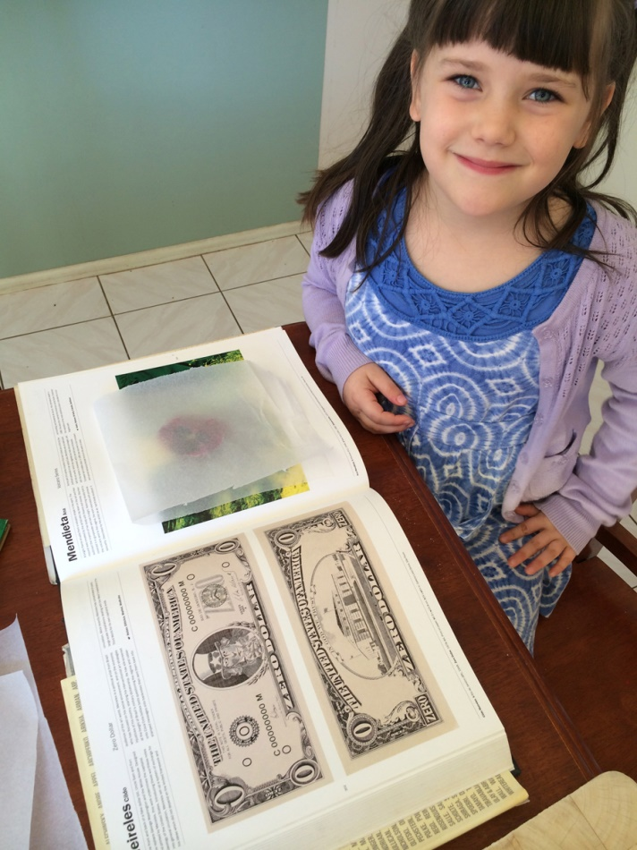

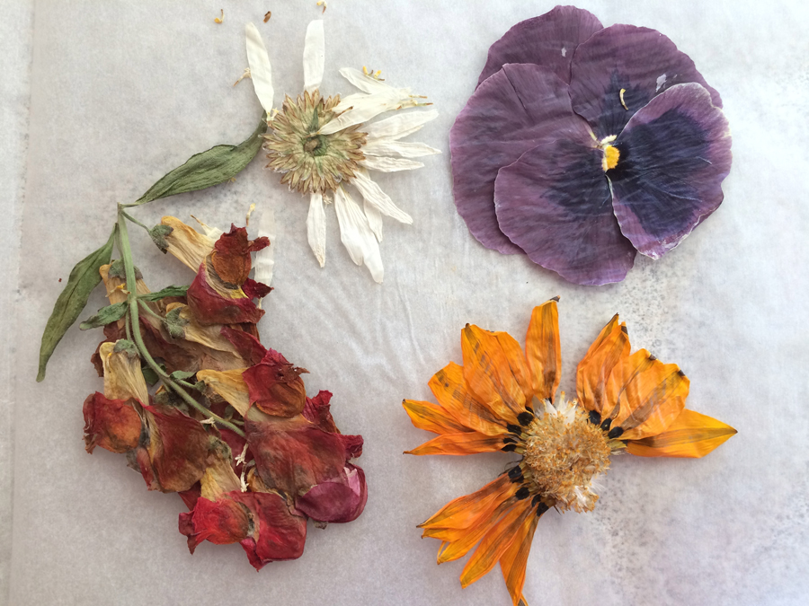

Pressing flowers is so much fun and best of all you can use them in a variety of craft activities from papermaking, decorating photo frames to bookmarks and potpourri.
If you plan to use your pressed flowers for future craft projects, store them in a dry air-tight container to avoid exposure to moisture.
Happy Pressing!

