Fruit Sorbet

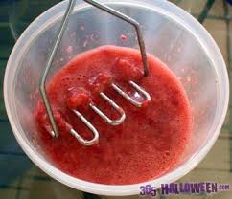
Take 1 packet of frozen raspberries or blackberries or strawberries - defrost and soften
Puree with a blender until very soft or mash until very soft
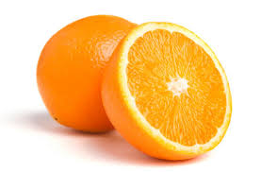
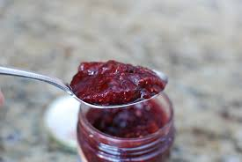
Mix in 1 large tablespoon of jam and the juice of an orange

Place in a container to freeze or in lollipop moulds.
Freeze for a few hours

Fruit Yoghurt Ice cream
Take 1 packet of frozen raspberries or strawberries and allow to defrost

Mash the fruit in a bowl with a potato masher until very soft or puree in a blender
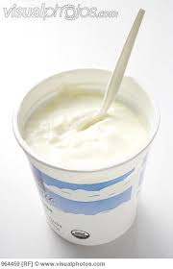
Mix in 1 large tablespoon of jam and 1 large pot of natural low fat Yoghurt,
Place in a container or lollipop moulds to freeze
Leave to freeze for a few hours
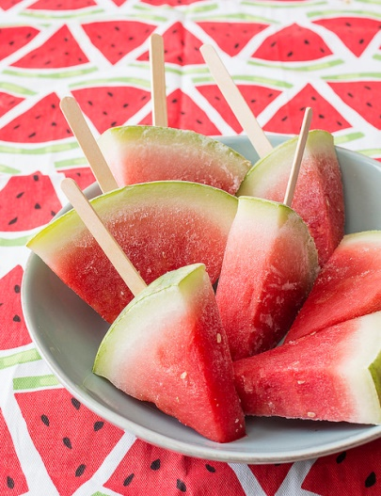
Watermelon ice lollies:
From:
https://www.chopchopfamily.org/recipe/frozen-watermelon-popsicles/
- Cut across ¼ of a watermelon to make wedges about 1-inch thick.
- Carefully cut a slit into the rind of each wedge and put a lolly stick into each slit.
- Arrange the wedges on the baking sheet
- Freeze until firm, at least 3 hours
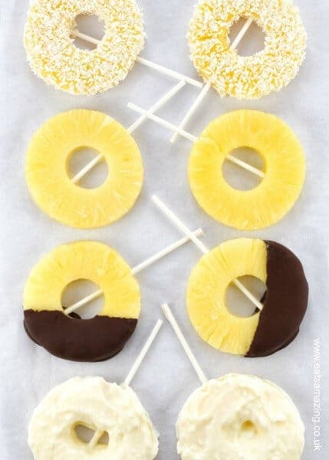
- Take out of the freezer 10 minutes before serving

Pineapple ring ice lollies:

From: https://www.eatsamazing.co.uk/family-friendly-recipes/snack-ideas-recipes/super-easy-pineapple-ice-pops-recipe-4-ways

- .Drain the pineapple slices
- Carefully push a cake pop or lolly stick into the side of each pineapple ring all the way through to the other side
- Place the pineapple rings on the lined baking tray
- Freezer for a couple of hours
- Serve immediately as they are, or try one of the variations on the website with chocolate, yoghurt or desiccated coconut
Other refreshing ice lolly recipes can be found on:
https://www.bbcgoodfood.com/howto/guide/how-make-homemade-ice-lollies
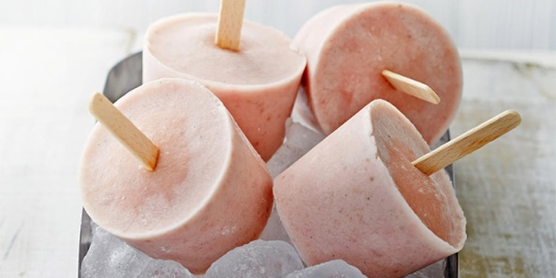paper cups can be used for moulds!

