Peppermint Creams
This easy recipe does not require any cooking!
To make the most of the sensory aspects of cooking follow the tips in blue.
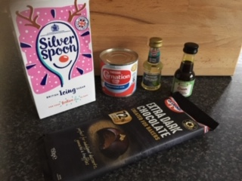 | You will need:  115g condensed milk  225g icing sugar  1-2 teaspoons peppermint essence  Optional: 55g dark chocolate for coating/ decoration
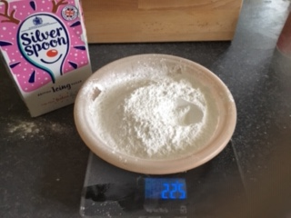 | Weigh 225g icing sugar  Sieve icing sugar into a bowl
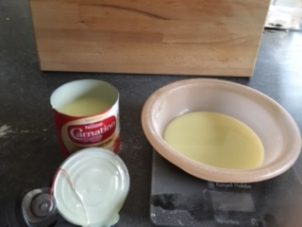 | Weigh 115g condensed milk  Pour milk into bowl with icing sugar  Allow participants to taste a small amount of condensed milk
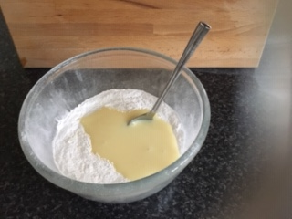 | Mix icing sugar and condensed milk
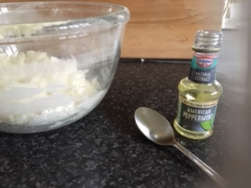 | Mix in 1-2 teaspoons peppermint essence  Encourage participants to smell the peppermint flavouring
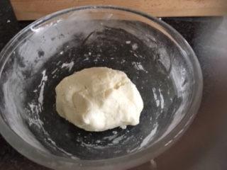 | Mix into a smooth dough  Encourage participants to knead and squeeze the dough with their hands
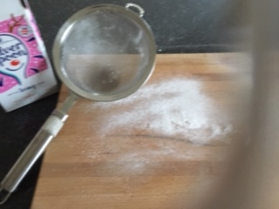 | Sift some icing sugar onto a clean surface, to stop the dough from sticking
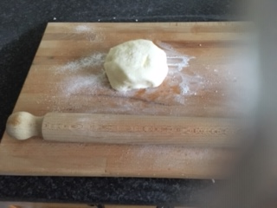 | Roll out the dough to about 5mm thick
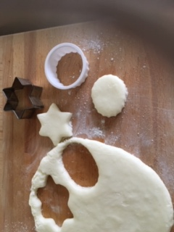 | Use small cutters to cut out shapes
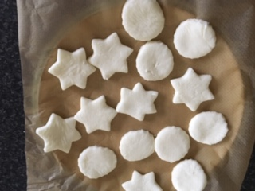 | Put the peppermint creams on baking paper  chill in the fridge for 1-2 hours  Encourage participants to feel the coolness of the creams  Enjoy!
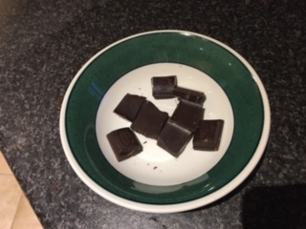 | If you want to add some chocolate decoration:  Break 55g of dark chocolate into squares  Either melt the chocolate in a microwavable bowl (heat it for short bursts of 20 seconds and stir in between),or melt the chocolate in a bowl over a pan of simmering water  Notice the smell of the chocolate and the shiny chocolate packaging
Dip the peppermint creams in the melted chocolate or drizzle chocolate over the top

Keep in the fridge in an airtight container

Eat within 3 weeks

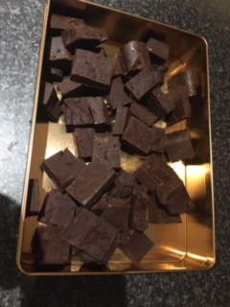
Chocolate fudge

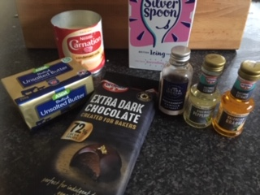 | You will need:  400g dark chocolate  397g condensed milk  110g icing sugar  25g butter  Optional flavourings: vanilla, orange, or peppermint essence
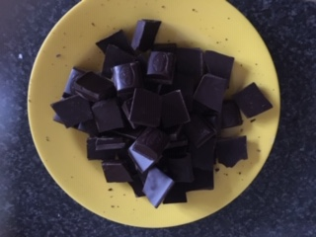 | Break 400g chocolate into squares  (milk chocolate and white chocolate can also be used and will make softer, sweeter fudge)  Notice the smell of the chocolate and the shiny chocolate packaging
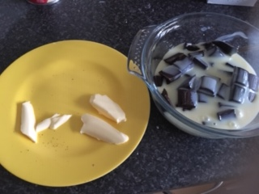 | Weigh 397g carnation milk  Weigh 25g butter
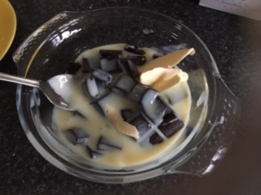 | Mix butter and milk with the chocolate
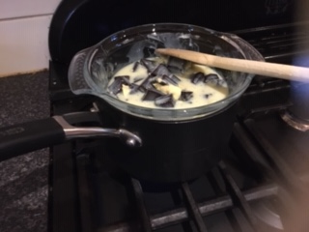 | Melt the mixture over a pan of simmering water  The mixture can also be melted in the microwavable bowl (heat it for short bursts of 20 seconds and stir in between for about 3 minutes in total),
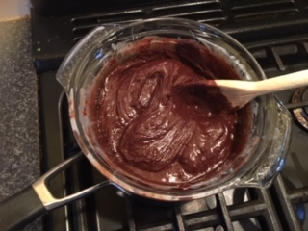 | Notice the chocolate melting and turning the mixture brown  When the chocolate has melted, take the bowl carefully off the heat
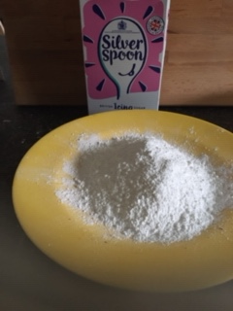 | Weigh 100g icing sugar
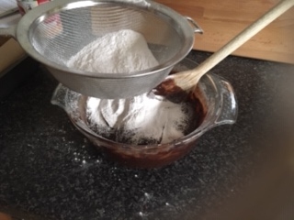 | Sieve the icing sugar into the mixture
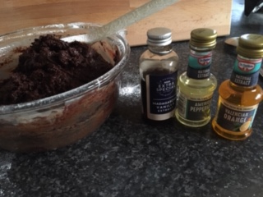 | The mixture can be divided and different flavourings added to each batch such as orange, peppermint or vanilla  Encourage participants to smell the different flavourings
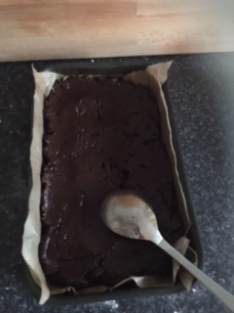 | Line a baking tray with baking paper  Press the fudge mixture into the tin  Smooth over with the back of a spoon  Taste some of the warm mixture
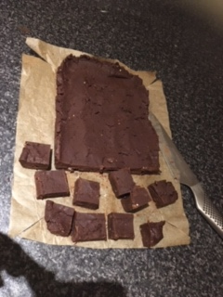 | Put the tin in the fridge  Chill for 1 hour  Remove the fudge from the tin and cut into small squares  Store in an airtight container in the fridge for up to two weeks  Note if participants prefer certain flavours of fudge

