Shamrock Crystals

How to make Borax Crystals
This is something you HAVE to try! The end result is amazing and they sparkle beautifully in the sun. I have seen a number of blogs around Christmas time that use borax crystals as ornaments, but we are now March and I am just getting around to making them so we made Shamrocks. I am tempted to make shapes for every season!
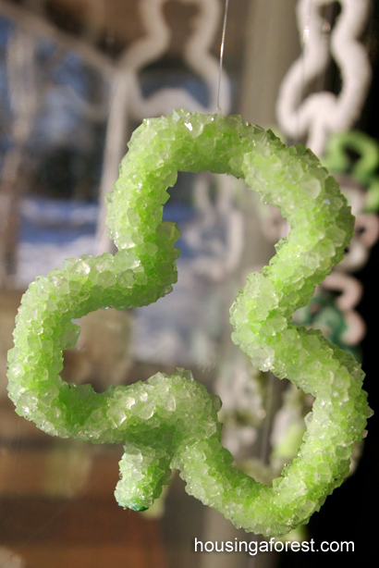

This Post contains affiliate links for your convenience

How to make Shamrock Crystals
- Borax
- boiling water
- a wide mouth glass mason jar
- green and white pipe cleaners
- string
- a pencil
- food coloring.
Borax can be found in the laundry isle. It is natural, but that does not mean it is safe. Borax should not me inhaled or ingested, so be careful.
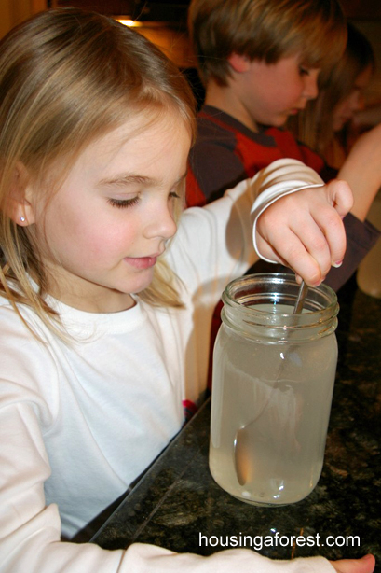

Instructions for making the crystals
First, twist your pipe cleaner into the desired shape. I set out a few templates of shamrocks (printed off the internet) for the kids to look at.
You will need 3 cups of boiling water per mason jar, 1/2 cup of Borax for each jar. The more saturated your solution is, the larger your crystals will be. Stir until all the borax is dissolved and the solution is clear, add food coloring if you desire.
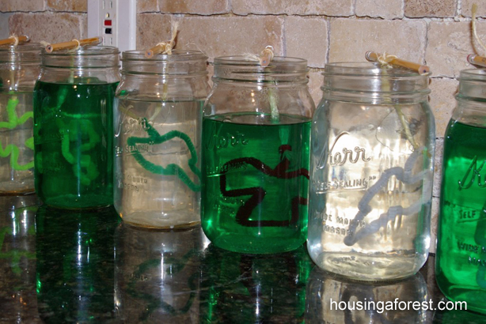
Tie a string around the tail of the shamrock and tie the other end to a pencil. Gently lower the shamrock into the solution making sure that it is not touching any sides or the bottom. Set the jar in a safe spot that will not be disturbed. We let ours sit overnight and the kids were amazed to find the pipe cleaners were transformed into crystal-encrusted decorations. Gently cut off the string and display in your window.
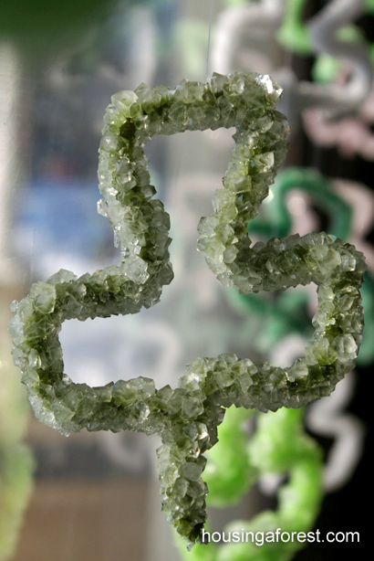

Shamrock Crystal Sun Catcher
These crystals are so simple to make. Kaleb loves to experiment so this was the perfect project for him. I loved that he added his twist on the experiment by coloring one pipe cleaner with markers to see what would happen. Next time I will encourage him to use sharpies instead of washable markers.
