Create your sensory garden
- Activity area
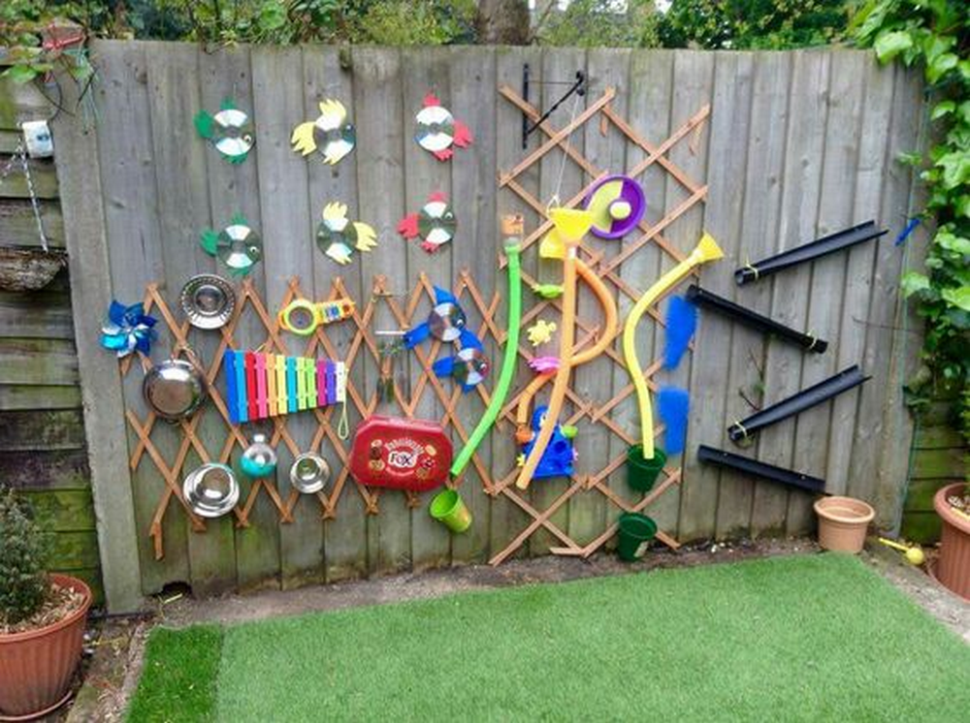
- Olfactive area: You can plant aroma plant/herbs in raised bed or even wellies if you want
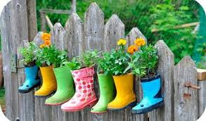

- Visual area
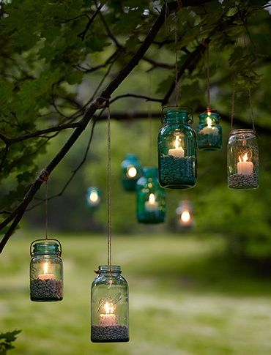For more safety you can use battery candles ( e.g: Poundland’s ones)
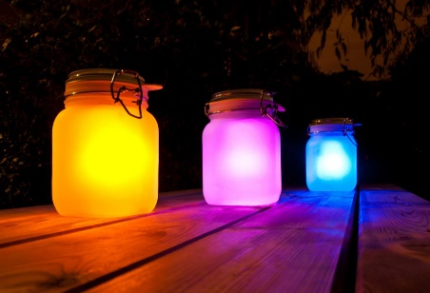 use see-through coloured paper or paint your glass jar then use battery candles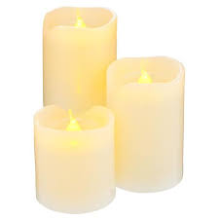 or 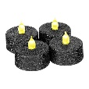 or 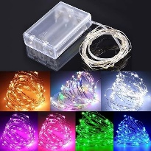
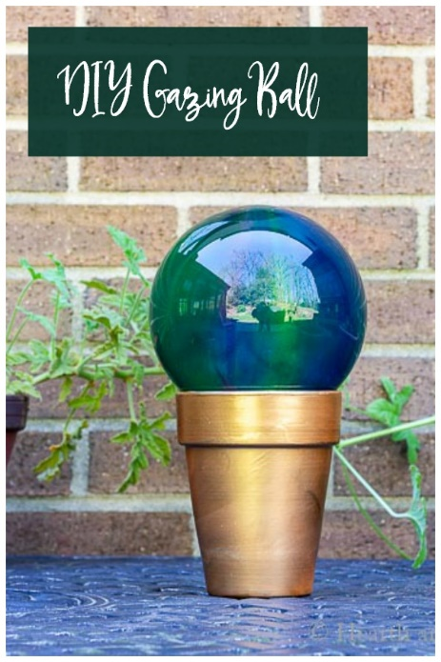
- Gazing Balls You Can Make For Your Own Garden | Hearth and Vine

- Audio area: You can make your own wind chimes if you want.
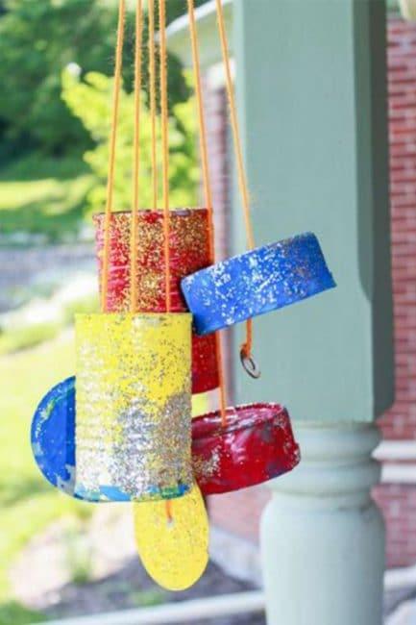 Homemade Wind Chimes the Kids Can Make! | Hands On As We Grow®
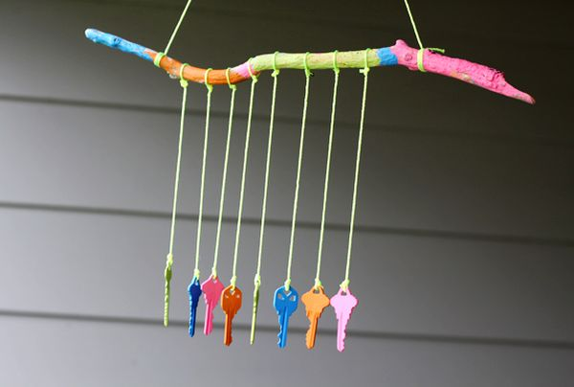 How to Make Your Own Wind Chimes - 15 Amazing Ideas (homedit.com)
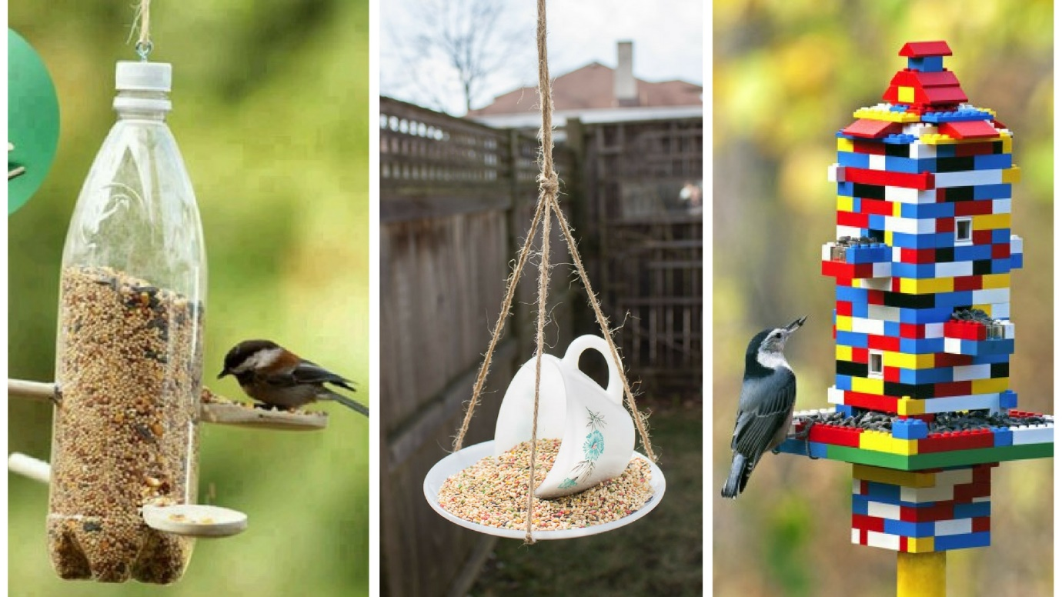
10 Simple Ways to Make a DIY Bird Feeder - The Handy Mano (manomano.co.uk)

